# **Folder Structure:**

The folder structure of the invoice generation program is attached below:

* **LUT** folder should contain the LUT document in **“.pdf”**.
* **upload** folder should contain the **“.xlsx”** file of invoice records.
* 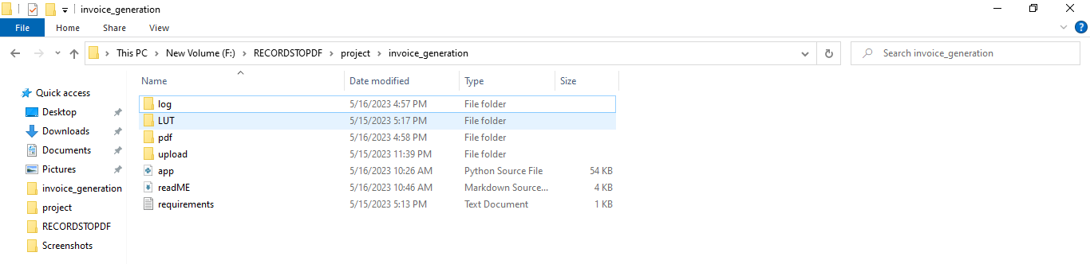**pdf** folder contains the invoices and LUT attachment in a single “pdf” for the records in the upload folder.

# **Step 1:**

* Click on Start menu
* 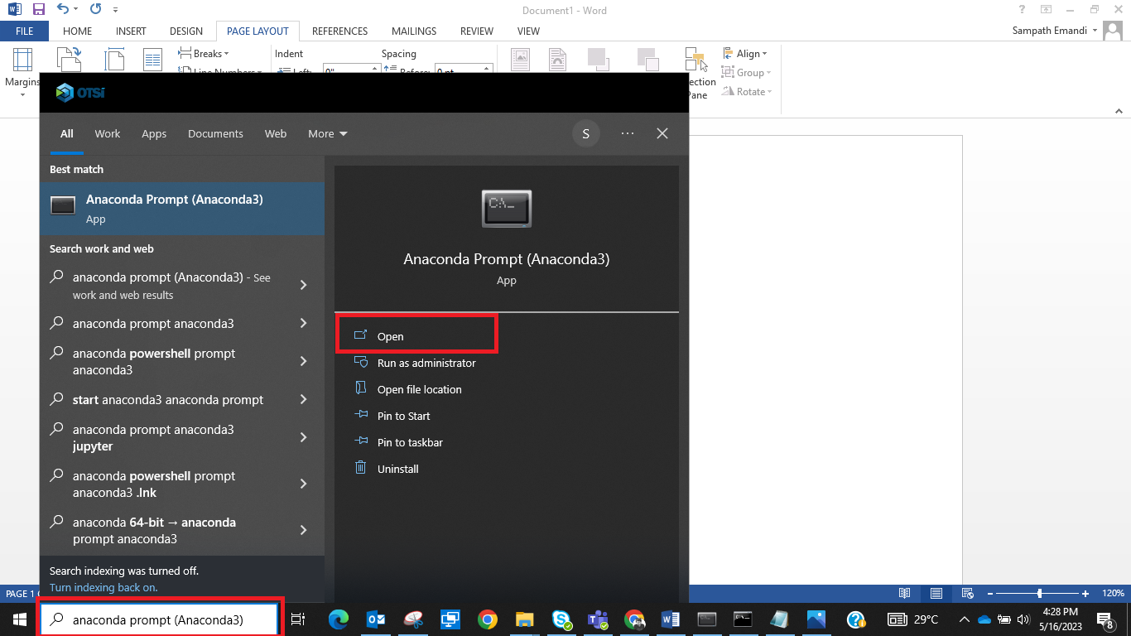Type “Anaconda Prompt” in the search bar > click open as shown in screenshot

# **Step 2:**

* A pop up window of **“Anaconda prompt”** opens up as shown

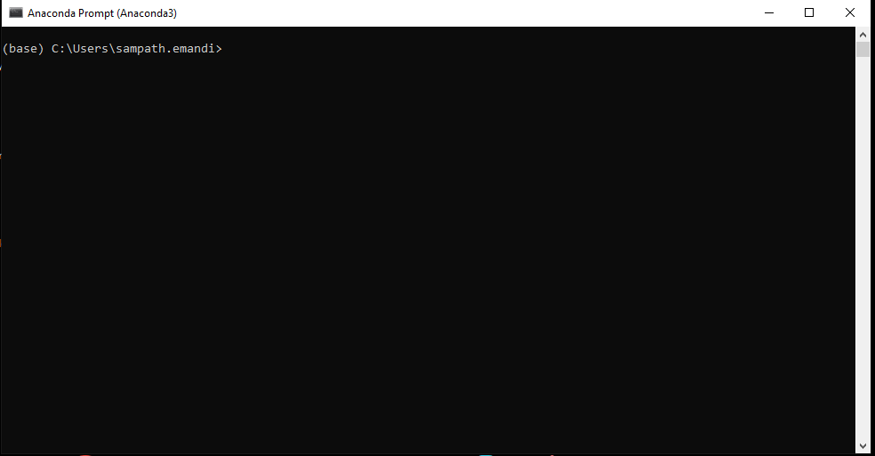

* Type ***conda activate - invoice_generation*** in the prompt and click ↵ Enter

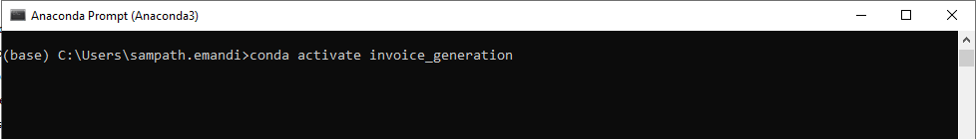

# **Step 3:**

* Observe a change in the environment

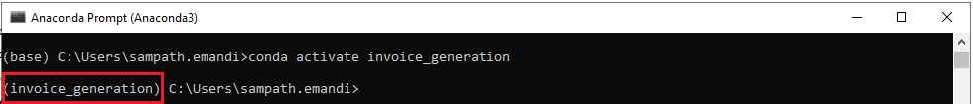

* Copy the project path past in the Anaconda Prompt. Click ↵ Enter
* Give the drive name as shown below “F:”

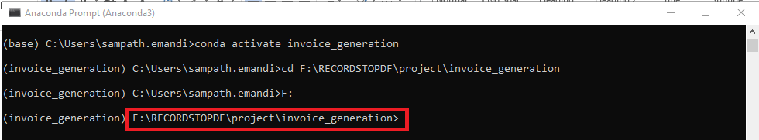

* Observe a change in the path to the “***invoice_generation”*** folder

# **Step 4:**

* Now you are ready to run the file and generate the invoices
* Type

***(i) python app.py -f "<fileName.xlsx>" -l "<fileName.pdf>"***

***(or)***

***(ii) python app.py -filename "<fileName.xlsx>" -lut "<fileName.pdf>"***

*Example: python app.py -f "billz.xlsx" -l "LUT Copies_2023-24.pdf"*

* You will observe the file running and output pdfs are found in the “pdf” folder